St. David’s Pupil Council
2014 – 2015
In St. David’s health promoting school, our children have an important part to play in making decisions about the life and work of the school. One of the ways in which children can have their say and make sure that their views and ideas are listened to is through the pupil council.

What is a Pupil Council?
A pupil council:

- gives our children the chance to tell teachers, staff parents and other children their ideas
- represents each class in the school
- meets regularly to talk about important school issues and projects
- puts forward the class views at council meetings
- take forward the views of the very young classes, who may find it difficult to put forward other's opinions.

The pupil council must have:

- a constitution, which is a list of rules clearly setting out roles and responsibilities –
see the display for our responsibilities and roles

- a chairperson, who leads the meetings by following the agenda, which is a list of items to be discussed –
our chairperson is Abbi and Nathan from Primary 7

- a secretary, who takes notes of what is said at the meeting – these notes are called the minutes of the meeting –
our secretary is Erin and Dean from Primary 6

- a link teacher, to give guidance and support –
our link teacher is Mr. Currie, Head Teacher

- a representative, who takes the key messages from each meeting back to the whole class to keep them involved
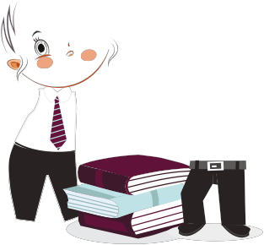

What happens during and after a pupil council meeting?
Before the pupil council meeting:
- Pupil Council reps agree the theme for each meeting based on the schools’ vision, values and aims and on the agreed action plan for the year
- Every class discusses the agreed theme with their teacher (maybe instead of milk/story time one day per week) and provides ideas, comments, suggestions etc for the reps to take to the pupil council meeting – this makes sure that every child in our school is involved and has a voice
- Reps from each class make sure they know and understand what they have to take to the meeting
During the pupil council meeting:
- important issues are discussed, ideas shared and action points decided
- discussions must be orderly and fair, with everyone having an equal opportunity to talk or be listened to
- the chairperson should make sure that representatives show respect for each other.
After the meeting:
- representatives report back to their class while things are still fresh in their minds - this helps every pupil to feel involved
- teachers must give enough time to let the class discuss points that have been raised
- a class or school suggestion box can be used to gather ideas throughout the week: these can be discussed by the class before agreeing to present to the Pupil Council.

What are the benefits of a pupil council?
The pupil council:
- involves you in decisions that affect you, your class and your school
- keeps you informed about the life of the school
- helps you to gain the confidence to have your say
- helps you to feel good about your place in the school community
- gives you responsibilities and encourages you to be an active citizen
- gets exciting issues moving
- deals quickly with issues that trouble you.

Get involved in our pupil council. You can make a difference!
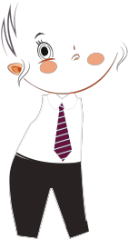
St. David’s Pupil Council
Action Plan

2014 – 2015

- Improve Learning at St. David’s
- Continue charity fundraising
- Improve our school Playground
- Continue to make our school fun!

St. David’s Pupil Council
Roles and Responsibilities

- Elected to represent their class.

- Respect others and their ideas.

- Responsible for improving our school.

- Our Pupil Council organise activities for all children to be involved.

- Our Pupil Council meet regularly with the Head Teacher.

- Our Pupil Council communicate their achievements to the whole school community

- Our Pupil Council make a difference to our school!!!

