
St David’s Primary School Parent Council Newsletter
June 2015

Welcome to a quick update on a few exciting developments from the Parent Council. As always, it has been a very busy but successful year and summer is nearly upon us. However before we get there, we would like to update you on a few things coming down the track!

BREAKING NEWS – PLAYGROUND PROJECT FUNDING SECURED!!!!

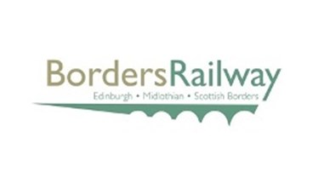

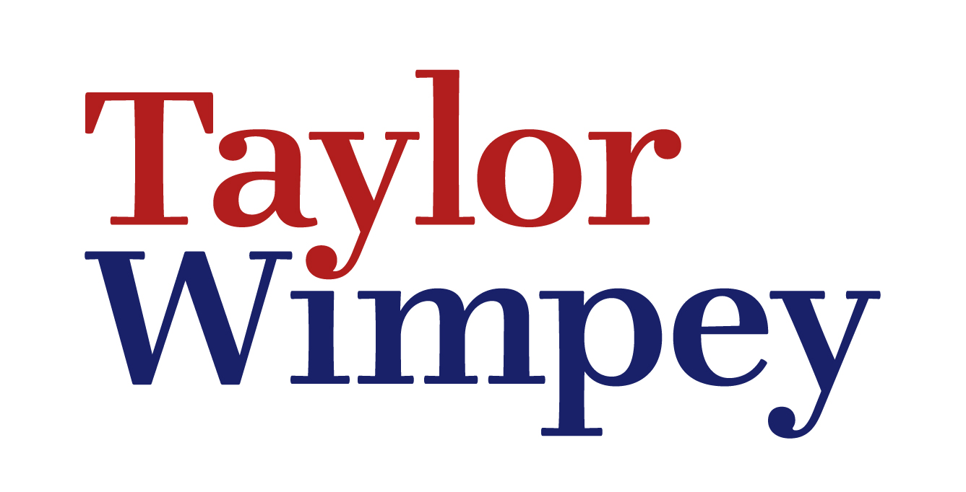

Those of you who have been at the school a while will know that we have been going on about the playground project quite a lot! The focus of our fundraising efforts for the last few years has been to secure the funding to significantly improve the playground for our children, and we have slowly but surely been inching towards our target. Up until the last month or so, the main assistance outwith our own efforts has been a fantastic contribution from Taylor Wimpey last year that helped with the Community Clean Up as well as going some way towards covering the cost of the traversing wall.

Thanks to a lot of effort on the part of a number of people, we have been able to secure some equipment from Buccleuch Estates, which they no longer need due to the upgrade at Dalkeith Country Park, and we can use as part of the new playground. The school has £2,000 available to it from Midlothian Council, and the Parent Council have raised £2,000 from the various successful events over the last few years, but that still unfortunately falls short of the estimated £6,500 cost of a great new playground experience. We had hoped to raise at least £1,000 from the recent Race Night, leaving a gap of £1,500. Are you still with us?? Turn the page…………………………

We are DELIGHTED to let you know that this gap will be filled by Borders Railway and Network Rail!!!! Following a form filling exercise for a grant of a maximum of £250, they got in touch to find out more about our plans, and after a bit more discussion and some gentle persuasion, they agreed to hand us £1,500 as long as we raised a minimum of £1,000 from the Race Night. Hopefully you will agree that this is FANTASTIC news, the end of a long hard slog, but it will be worth it in the end!

So, we only had to do two things – raise £1,000 and design and order the playground. Both are now DONE!! We have asked our contact at Midlothian Council to go ahead, and are waiting for confirmation of a date. It would be great if we could have this in place before the end of term, so as the P7’s could at least see it before they leave, but it is looking more likely to be installed over the summer so they will just have to pop back to see the results. Watch this space!



HELD ON FRIDAY, 22ND MAY AT DALKEITH RUGBY CLUB

This year’s Race Night was held late last month, and it was another fantastic night. It was great to see so many new faces, hopefully everyone enjoyed themselves! We had set a target of a minimum of £1,000 and it is safe to say we did a little better than that – we raised over £2,100, which is the best yet!! Thank you to everyone who came along, who helped before and during the night, who placed bets, bought horses, sponsored races, placed adverts, bought raffle tickets, bid for prizes etc etc. It was a real team effort and the fruits of our labour are just round the corner now!

Same time next year everyone?

PLAYGROUND CLEAN UP – PART 2 – SATURDAY 20TH JUNE

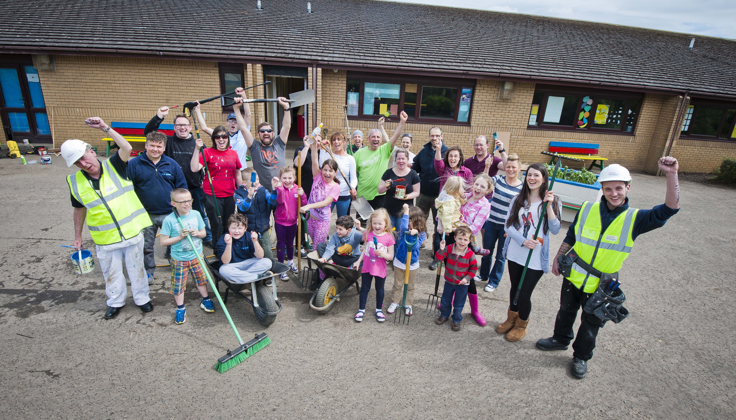

Last year, a hardy bunch of parents, grandparents, pupils, teachers, friends and two helpers from Taylor Wimpey came together for a couple of days and made a huge difference to the school grounds. We are looking to come together again in June to do a bit more! So if you are happy to come along and muck in, and do whatever is needed to just make things better (cleaning, weeding, gardening, painting, etc etc etc), please contact stdavidsdalkeithpc@gmail.com and/or look out for more information soon! The more people who can make it, the more difference we can make. Those of you who volunteered before, we still have your details, no pressure……!

HOW CAN YOU FIND OUT MORE?
If you are on Facebook and/or Twitter and haven’t joined us yet, please look for:

Click on www.twitter.com
@stdavidsparentc on Twitter and click ‘Follow’


Click on www.facebook.com/groups/118580941631754
and join the group!

Kind regards, The Parent Council members

