£6804 allocated to St David’s R C Primary Session 2018/2019 to help reduce the Cost of the School day.

Free healthy snacks  - healthy snack box for each class will be purchased and given to each class to be filled with healthy, long life snacks per term i.e. breakfast bars, raisins etc  - £304.20 will be split across 4 terms for this.  - classes have created healthy snack ideas which have been shared with the Parent Council | 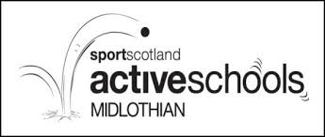  Afterschool clubs/ activities  - focus on a wider range of clubs/range of activities and looking how to make them more accessible  - tournaments/festivals will be attended throughout school year through Active Schools/ Festivals – Miss Whyte is leading on this and funds could contribute to transport costs  - investigating use of this money to provide additional clubs/ activities within the school day to maximise participation  - further discussion required here | 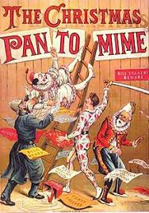  Pantomime/ Brunton Theatre  - booked for 29th November at Brunton Theatre, Musselburgh  - final ticket, transport prices and times still to be finalised | 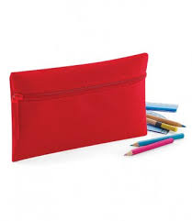  Pencil case for every student  - pack of pencil, rubber, rubber and metal sharpener could be given to each child with names labelled – concerns raised by school and Parent Council about how to ensure this money is well utilised by buying quality resources  - possibility of a class stationary box being purchased for each class with different, creative resources for art based activities  - further discussion required here | 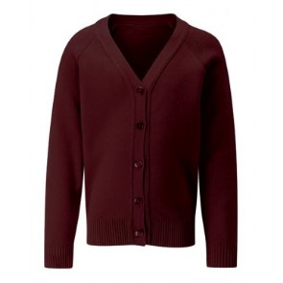  Thrift Shop  - Supply of gym kits will be available for kids who don’t have one on a loaning basis. These would remain in school and be laundered termly  - dependent on numbers, gym shoes could be purchased for each child who currently does not have them - the intention would be that these were recycled/ gifted back into the Thrift Store  - Parent Council intend to manage all the laundering in house  - Mrs Culbertson will lead on this and supported with uniform Lost Property with non uniform being laundered and gifted to local charity, The Button Box  - school ties and iron badges will be available through the Thrift Shop | 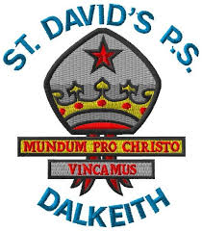  Iron on badges  - box will be held in school office with suggested donation of £1.50 if people would like to buy a badge and free to the families that need it  - badges will also be made available to families accessing the Thrift Shop  - Parent Council have sent for several samples to gauge quality and will feedback on next steps | 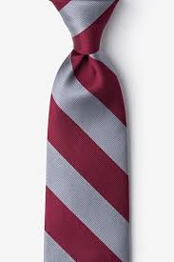  School tie for Primary 1 pupils  - 24 P1 pupils to receive school tie  - New pupils in P2 and P4to receive a school tie  - ties to be presented to pupils on Wednesday 26th September with Parent Council and LLE attending  - ties have been priced at £5 per tie

